Project Design Phase
Solution Architecture

Date | 18 Feb 2026
Team ID | LTVIP2026TMIDS80588
Project Name | TransLingua: AI-Powered Multi-Language Translator
Maximum Marks | 4 Marks

Solution Architecture:
- Goal: To bridge the gap between foreign language accessibility and user productivity using the Gemini 3 Flash model.
- Structure: A 3-tier architecture consisting of a Streamlit Frontend, a Python Backend (SDK), and the Google Gemini API for processing.
- Behavior: The system accepts multimodal inputs (PDF/Image), extracts text using OCR, translates it while maintaining context, and returns a formatted document.
- Specifications: High-speed processing using "Flash" series models with an automated failover to Gemini 2.5 for reliability.

Example - Solution Architecture Diagram:

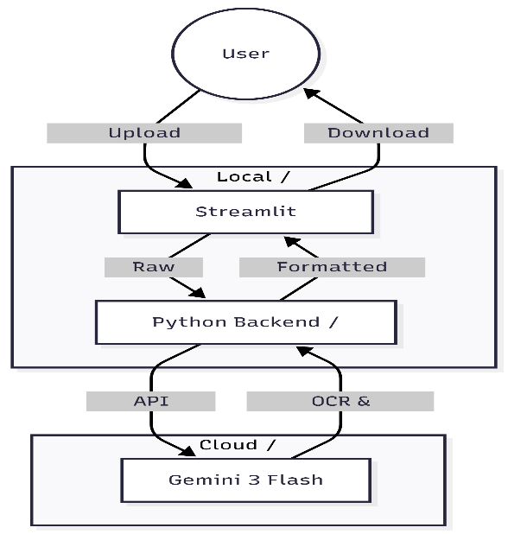
Figure 1: Architecture and data flow
Reference: https://ai.google.dev/docs
https://docs.streamlit.io
https://c4model.com/
https://pypi.org/project/google-genai/

